Learnings:
- Building datalake from scratch from s3
- Joining semi-structured and structured data
- Lake house arch design
- Best practice - cost and performance
- Datalake vs datawarehouse
- Datalake design in layers, partitioned for cost performance
- WORM model, write once, read many
- Aws data catalogue
- ETL in AWS glue spark job
- AWS SNS for alerting
- SQL using amazon athena and spark sql
- Ingest changes incrementally and schema evolution
- BI dashboards and amazon quicksight

Dataset Used:
Top trending dataset on Kaggle.
We will use cloud instead of on-premise data center,
Why not using on-premise data center:
- Buying hardware, costing and licensing.
- Shipping, instalization, electricity and cooling system.
- Underutilization and overutilization.
- Pay even no body is using the hardware.
- Sustainability issues.
Tips:
- Always use iam account
- Enable MFA (google authenticator)
- Rotate all keys and passwords periodically
Dataleke: centralised repo where we can store all our data at one location.
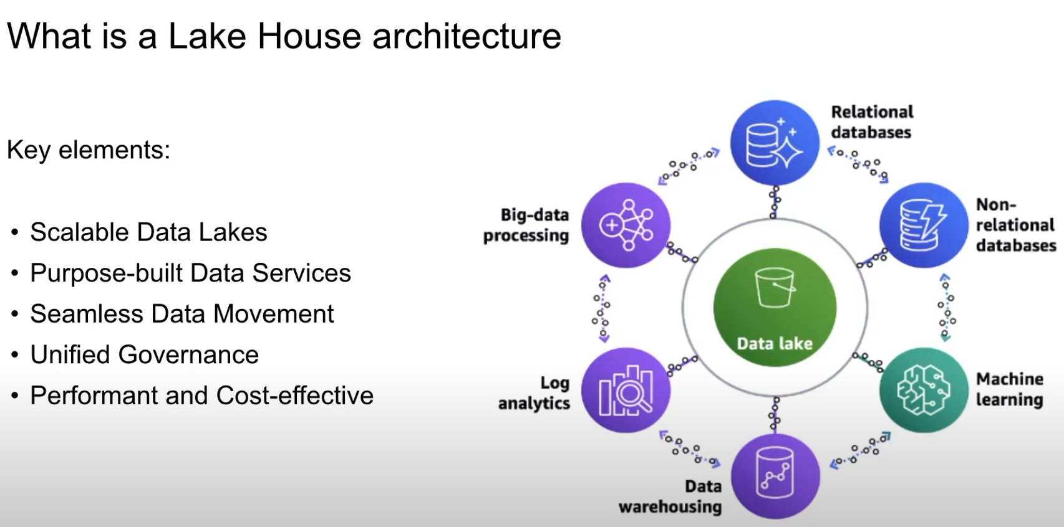

Using this datalake, we can build various data warehouses, ml morels, rdbms etc.
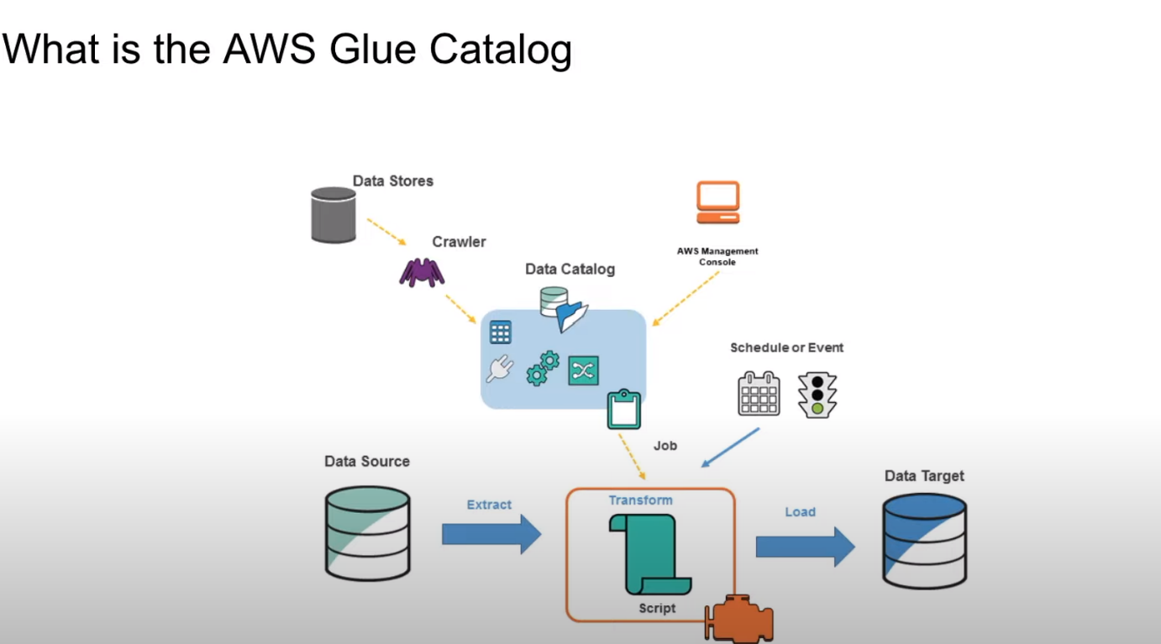
Data Catalogue: contains information about our data

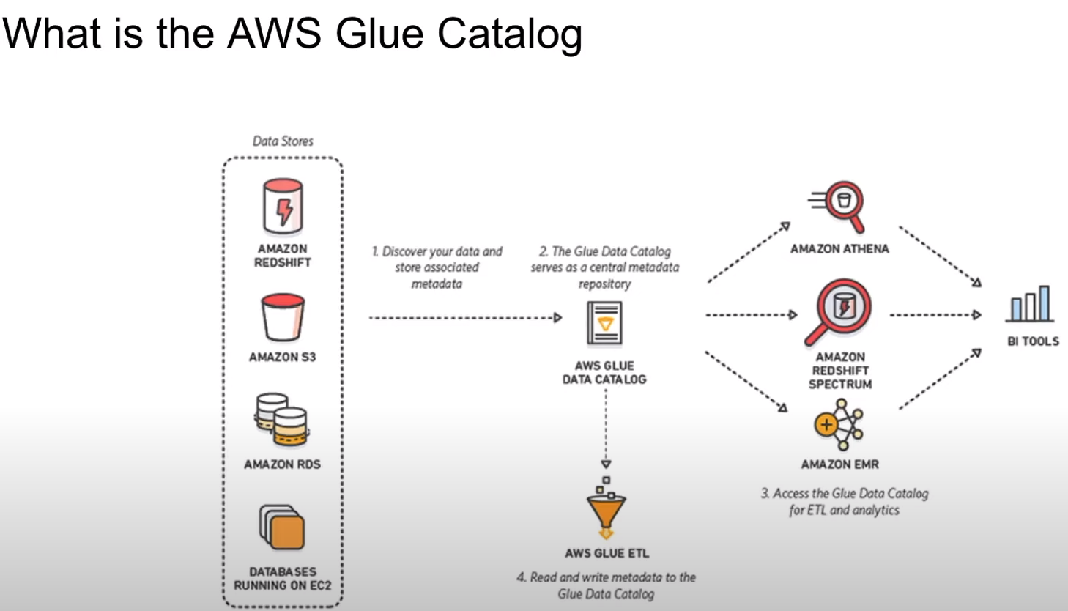
Create iam service for AWS Glue as it requires to access S3.
Providede 2 roles to iam service for glue to s3(check what were the roles)
Crawler job runs and analyses the data present in s3 and creates tables after analysing the data in s3.
Read more on parquet db.

Now we will be converting this json format to parquet format. For this we will be using AWS lambda, writing python code to normalize the data and then push it into s3.

AWS cli commands:
Aws configure
Aws s3 ls

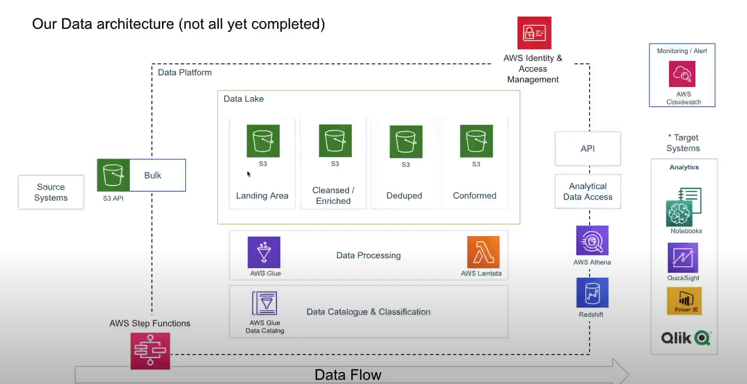

Steps:
- Create iam user account
- Download aws cli (https://aws.amazon.com/cli/)
- Create a s3 bucker naming de-on-youtube-raw-useast1-dev

